Assignment 2 Question 1 Documentation

15009851

Table of Contents

Introduction 2

Specifications 3

Flowchart And UML 5

Screenshots 6

Conclusion 12

# Introduction

We were tasked to make a file based app. We had learnt about different ways of using files including assets folder, shared preferences.

Shared preferences can only hold a max of 10.

Assets folder a limitation of not been able to clear the text file to rewrite from the beginning of the file so a password reset doesn’t work. It works in theory with the code which I have there.

I decided to make a login app, I was going to use implement it in to my question 2, but the assignment said we couldn’t merge them together. It would of worked out to go have gone well with it for an extra layer of security.

# Specifications

“Choose any problem that can be solved using a file-based application. Examples can include but not limited to a reservation system, a ticketing system, an address book, favourite places, tourist attractions in a specific city, top ten lists, events management, etc. You will need to conceptualise, design and code this app as follows:

• Design the files required for your system. You will need to store data and produce at least one report. The minimum requirement is one file and one report, but you may use as many as you deem necessary.

• Your file must contain records. • Design a GUI interface in XML using “View” components to capture new records as well as to display your report(s).

• Write code to allow a user to save all details from the GUI into a text file. Print out a success message detailing that the information has been successfully saved. Use a message (Toast class/ SnackBar or Notifications Bar) to indicate the success or failure of the file save as follows:

You may want to view your textfile and verify that it was created and saved. A search through your computer or within the project source files will not show this file. You need to use the DDMS. Use your text resources to assist you in finding and “pulling” this file to view it.

• You also need functionality to open the text file and display the information in a new Activity or Intent. This could be your report.

Also display a message to confirm that all data has been loaded. You can use the Toast class or ToolBar or SnackBar.

Use extensive exception handling to determine if the files (or any input) are invalid. Make use of the Toast class or ToolBar or AppBar to display error messages.

Research why your app does not need a traditional Exit button. However there is still a need to clear the stack of activities through programming and also stop any services and processes, e.g. GPS recording, which may be running in the background. Include this functionality in your app.

• Your app needs to include proper navigation as specified by the Google guidelines and standards.

• Feel free to add extra functionality into the program. You will be awarded appropriately.

• The above specifications are just a guideline; you may adapt this to your own styling and add other views like images, etc. You are also encouraged to increase the functionality; however the above is the minimum specification

N.B: 1. You are not allowed to combine this question with the next one.”

<https://portal.iie.ac.za/Student%20Manuals/OPSC7311_Open_Source_Coding_Introduction/2017/Assignment%202.pdf>

I have followed the Specifications given to us.

My android app requires marshmallow version of android.

Minimum specs

ram: 200mb

cores: 1 core

storage: 10mb

5’ display

android studio 2.2.3

android os: marshmallow

age: 9+

# Flowchart And UML

Are in its own folder

They are clear, just have to zoom in.

# Screenshots

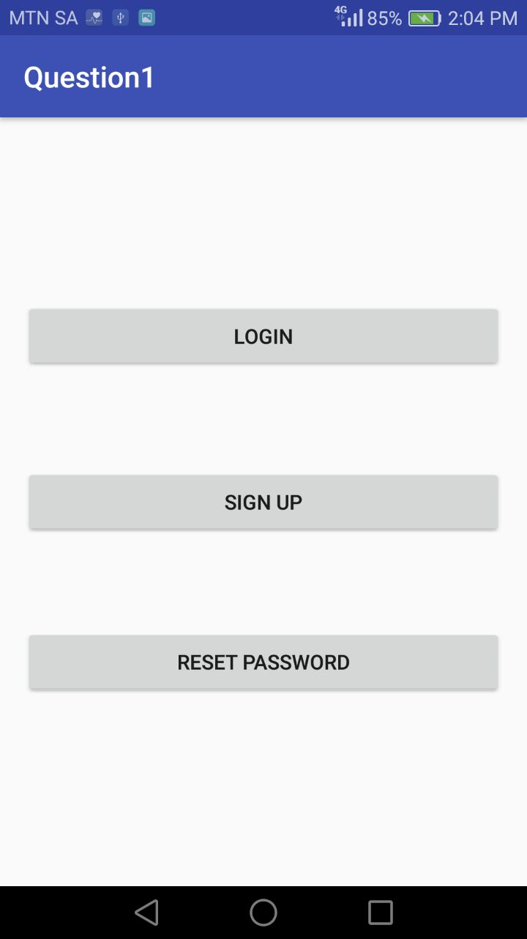

The loading activity

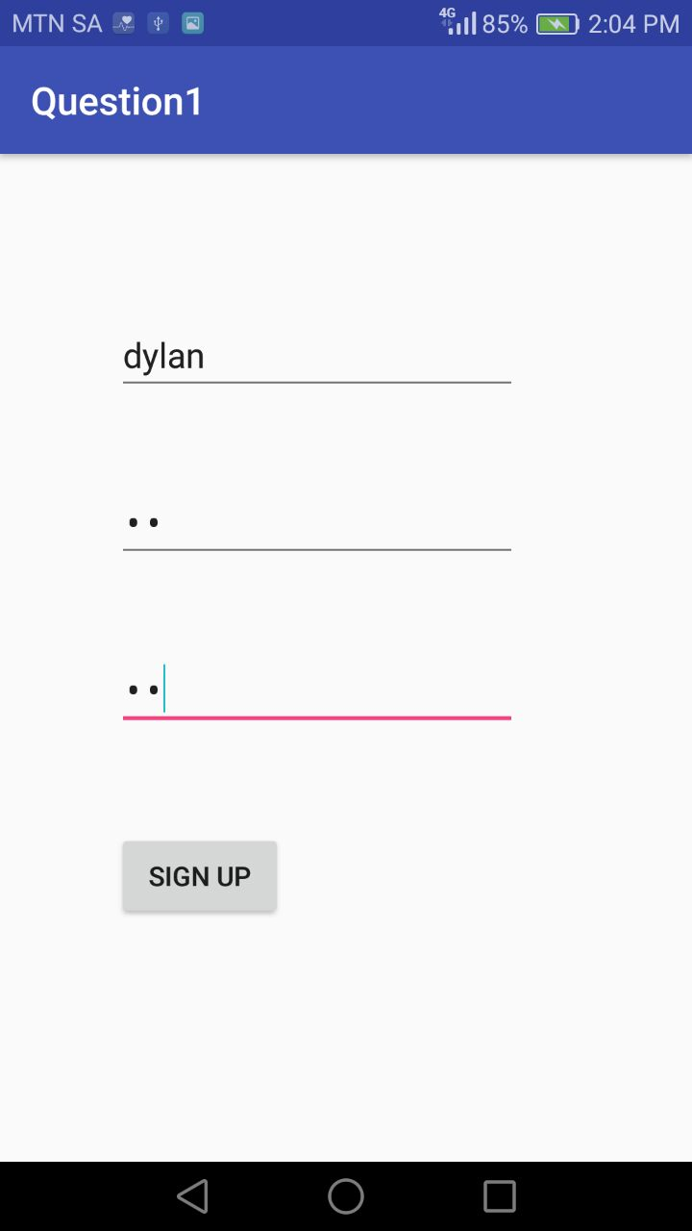

Signing up

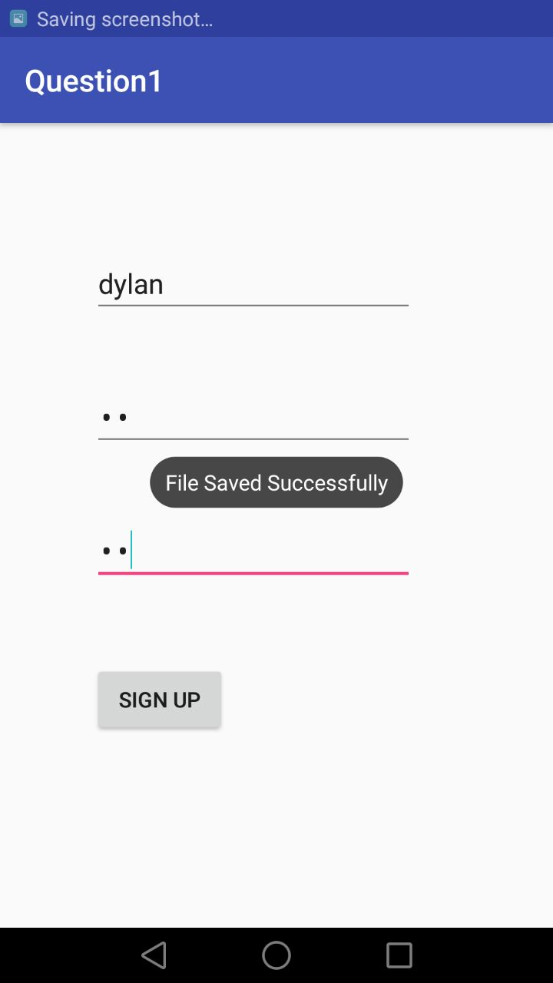

Saving the username

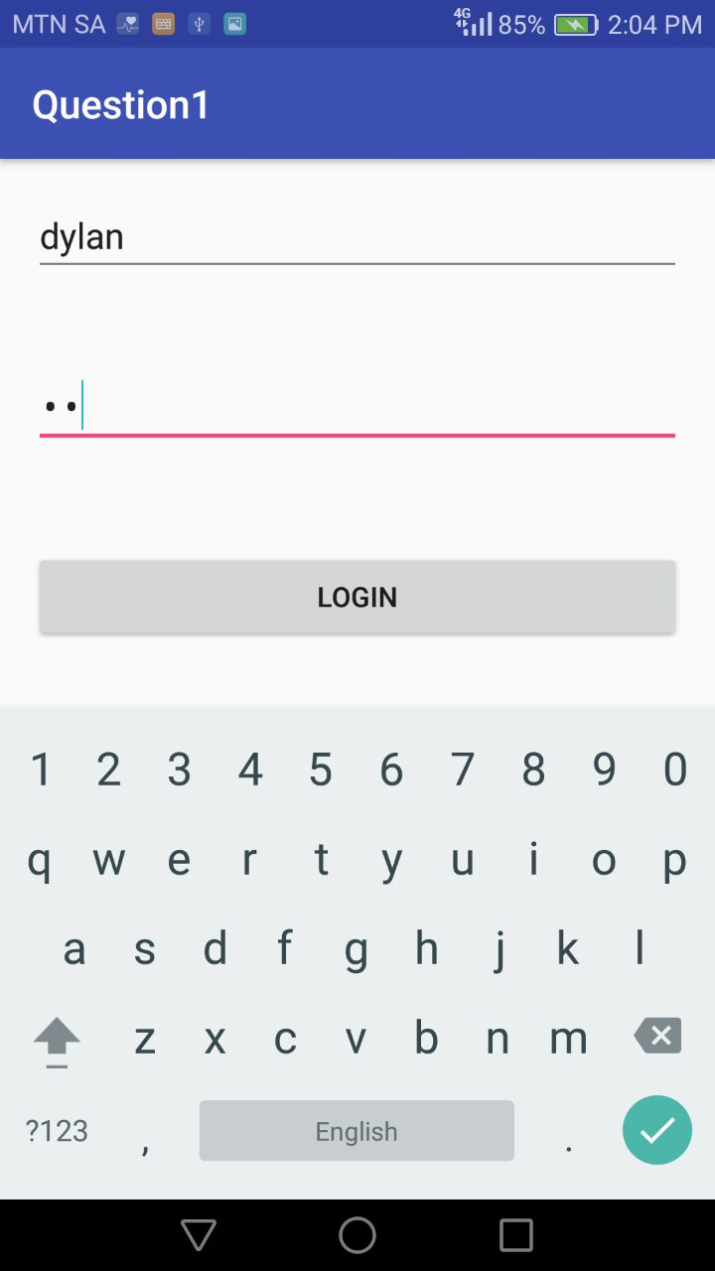

Signing in

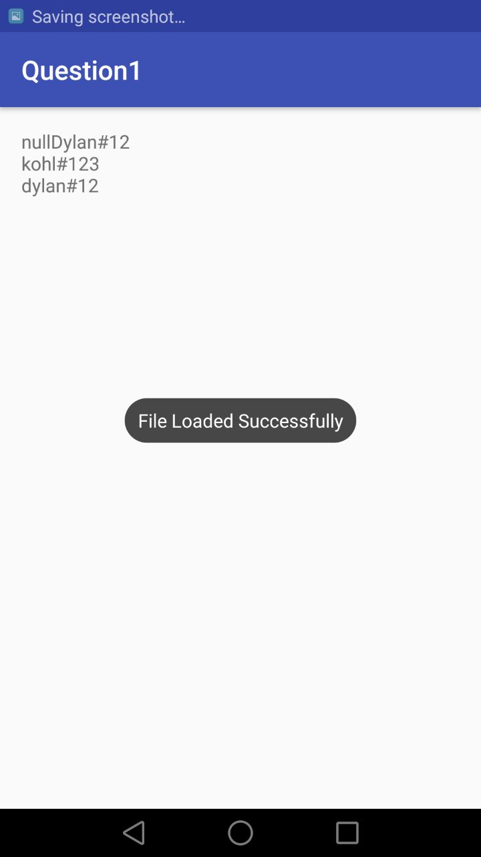

Once signed in you see a report

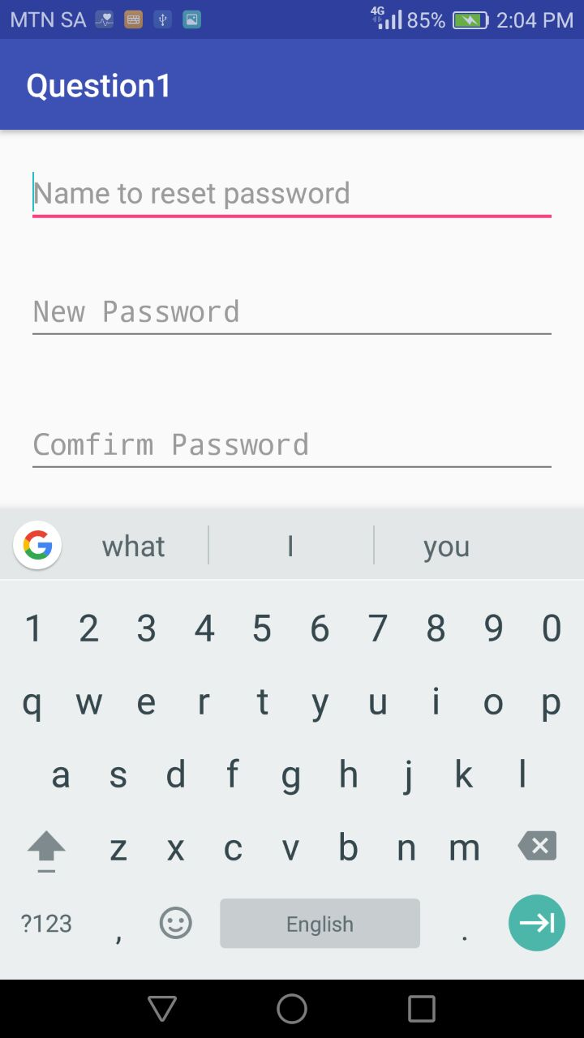

reset password

# 

# Conclusion

In conclusion the login works, tells you if your password is wrong.

It proceeds once correct details.

You can sign a user up and login.

There is a report of all the user details once you login.